CHAPTER | TOPIC | PAGE NO.
Chapter I | INTRODUCTION | (1-3)
1.1 | Overview………………………………………………... | 1
1.2 | Problem Statement……………………………………… | 1
1.3 | Objective of Project……………………………………. | 2
1.4 | Applications or Scope…………………………………... | 2
1.5 | Organization of Report…………………………………. | 3
Chapter II | LITERATURE SURVEY……………………………... | (4-5)
Chapter III | METHODOLOGY……………………………………. | (6-9)
3.1 | Background / Overview of Methodology………………. | 6
3.2 | Project Platforms used in Project ………………………. | 6
3.3 | Proposed Methodology ………………………………… | 6
3.4 | Project Modules………………………………………… | 7
3.5 | Diagrams (ER, Use Case DFD, etc.) …………………… | 8-9
Chapter IV | SYSTEM REQUIREMENTS………………………… | (10-11)
4.1 | Software Requirements………………………………. | 10
4.2 | Hardware Requirements……………………………… | 11
Chapter V | EXPECTED OUTCOMES…(with GUI)…………… | (15-17)
Chapter VI | CONCLUSION & FUTURE SCOPE………………. | (18-19)
6.1 | Conclusion……………………………………………… | 18
6.2 | Future Work……………………………………………. | 19
6.3 | Long Term Vision………….. | 19
Chapter VII | REFERENCES………………………………………... | 15
Chapter VII | Weekly Report (Xerox / Original) | -

MINOR PROJECT REPORT

Submitted in partial fulfillment of the requirement for the Degree of Bachelors of Technology in Computer Science & Engineering

Submitted To:



[PARUL UNIVERSITY, VADODARA, GUJARAT (INDIA)]

Submitted By:

Raghav Singhal (2203051250010), Tanish Chakote (2203051250004), Chitransha Bhati(2303051250003),
Abhiman Gaurav (2303051250001)

Under The Guidance of: Hardik Rathod
(Ass.Professor, CSE)

DEPARTMENT OF COMPUTER SCIENCE & ENGINEERING

PARUL INSTITUTE OF TECHNOLOGY VADODARA, GUJARAT

SESSION: AY 2025-2026

Parul Institute of Technology

(Session: 2024 -2025)
DEPARTMENT OF COMPUTER SCIENCE & ENGINEERING
CERTIFICATE

This is to certify that ………… (“Raghav Singhal, Tanish Chakote, Chitransha Bhati, Abhiman Gaurav”) .…………, Students of CSE VI Semester of “ Parul Institute of Technology, Vadodara” has completed their Minor Project titled “ATHLINK”, as per the syllabus and has submitted a satisfactory report on this project as a partial fulfillment towards the award of degree of Bachelor of Technology in Computer Science and Engineering under Parul University, Vadodara, Gujarat (India).

HARDIK RATHOD Asst.Prof. Sumitra Menaria
(Project Guide) Head (CSE)
(Ass.Pofessor) PIT, Vadodara
(CSE)

DECLARATION

We the undersigned solemnly declare that the project report “ATHLINK” is based on my own work carried out during the course of our study under the supervision of HARDIK RATHOD, Ass.Professor, CSE.

We assert the statements made and conclusions drawn are the outcomes of my own work. I further certify that
- The work contained in the report is original and has been done by us under the general supervision of our supervisor.
- The work has not been submitted to any other Institution for any other degree / diploma / certificate in this university or any other University of India or abroad.
- We have followed the guidelines provided by the university in writing the report.

Whenever we have used materials (data, theoretical analysis, and text) from other sources, we have given due credit to them in the text of the report and giving their details in the references.

RAGHAV SINGHAL [2203051200010]

TANISH CHAKOTE [2203051200004]

CHITRANSHA BHATI [2303051200003]

ABHIMAN GAURAV [2303051200001]

ACKNOWLEDGEMENT

In this semester, we have completed our project on “ATHLINK”. During this time, all the group members collaboratively worked on the project and learnt about the industry standards that how projects are being developed in IT Companies. We also understood the importance of teamwork while creating a project and got to learn the new technologies on which we are going to work in near future.

We gratefully acknowledge for the assistance, cooperation guidance and clarification provided by “HARDIK RATHOD” during the development of our project. We would also like to thank our Head of Department Prof. Sumitra Menaria and our Principal Dr. Swapnil Parikh Sir for giving us an opportunity to develop this project. Their continuous motivation and guidance helped us overcome the different obstacles for completing the Project.

We perceive this as an opportunity and a big milestone in our career development. We will strive to use gained skills and knowledge in our best possible way and we will work to improve them.

RAGHAV SINGHAL [2203051200010]

TANISH CHAKOTE [2203051200004]

CHITRANSHA BHATI [2303051200003]

ABHIMAN GAURAV [2303051200001]

LIST OF FIGURES
 | S. No. | Figure No. | Name of Figure | Page No.
 | 1 | Fig. 1.1 | High-Level System Architecture | 8
 | 2 | Fig. 1.2 | Use Case Diagram of Athlink | 8
 | 3 | Fig. 1.3 | Data Flow Diagram for Event Registration | 9
 | 4. | Fig. 1.4 | Entity Relationship Diagram (ERD) | 9

LIST OF ABBREVIATIONS
 | S. No. | Abbreviation | Full Form
 | 1 | HTML | Hyper Text Mark Up Language
 | 2 | SDLC | Software Development Life Cycle
 | 3 | DFD | Data Flow Diagram
 | 4. | UI/UX | User interface / User experience
 | 5. | AI | Artificial Intelligence
 | 6. | CSS | Cascading Style Sheets
 | 7. | RBAC | Role-Based Access Control
 | 8. | ER Diagram | Entity-Relational Diagram
 | 9. | NPM | Node Package Manager
 | 10. | SQL | Structured Query Language
 | 11. | IDE | Integrated Development Environment
 | 12. | JS | JavaScript
 | 13. | DB | Database
 | 14. | API | Application Programming Interface
 | 15. | VS Code | Visual Studio Code

CHAPTER I INTRODUCTION

1.1 Overview
There is a significant operational and informational imbalance between professional coaching academies, organizational governing bodies, and grassroots athletes in the current local sports ecosystem. In the past, word-of-mouth referrals and various, unindexed social media groups have been major informal communication channels for local sports networking. The "ATHLINK" project was created as a centralized, web-based software platform intended to digitize and centralize these localized stakeholder interactions. It was also prototyped and referred to as "Play Grid" in concurrent technical documentation.

Problem Statement

The decentralized concept of sports, by definition, always leads to a sociological/athletic phenomenon called "Talent Leakage." "Talent Leakage" is defined as a condition where elite athletes do not benefit from critical developmental opportunities, coaching, or tournament registrations simply because of a lack of awareness or limited access to verified information. On the other hand, sports organizations, individual coaches, and sports academies face challenges such as scouting verified athletes, authenticating athletes' credentials, and dealing with logistical issues such as event management, marketing, and manpower recruitment.

Objective of the Project

To Develop a centralized Sports Networking platform: ATHLINK aims to build a centralized digital platform for sports industry stakeholders—players, coaches, academies, and organizations—to seamlessly connect, replacing the current fragmented system of informal channels and disjointed websites.

To Enable Players to Discover Nearby Coaches and Competitions: ATHLINK aims to improve access to local training and competitions by providing an advanced search system. Players can easily locate suitable coaches and academies by filtering for sport, region, age, and experience level.

To Provide Coaches and Academies with Player Management Tools: ATHLINK streamlines communication between coaches, academies, and interested players. Coaches can efficiently manage potential trainees by receiving requests, reviewing player profiles, and directly approving or declining applications.

To Allow Organizations to Manage Sports Events and Opportunities: ATHLINK provides sports organizations with event management tools for tournaments and workshops. It also features a listing system for staffing needs—including coaches, volunteers, and interns—connecting players and professionals with active opportunities.

To Implement Role-Based Access Control: ATHLINK implements role-based access control (RBAC) to enhance system security, ensuring that players, coaches, organizations, and administrators only access features relevant to their specific roles.

To Provide Administrative Control and System Monitoring: To ensure platform integrity and prevent misuse, ATHLINK provides robust administrative tools for validating profiles, monitoring events, and strictly enforcing policies like blacklist handling.

To Build a Scalable and User-Friendly System: The final objective is to design ATHLINK as a highly responsive, scalable, and intuitive platform that seamlessly supports concurrent users while remaining accessible to non-technical individuals.

Applications or Scope

ATHLINK democratizes grassroots and collegiate sports by providing a comprehensive management tool that streamlines operations for academic institutions, municipal ecosystems, and local associations like the Baroda Cricket Association.

    - Centralized Networking

Develop a web-based platform to seamlessly connect players, coaches, academies, and sports organizations.

    - Role-Based Access

Implement tailored dashboards and permissions for different user types to ensure a secure and relevant user experience..

Player Capabilities

Enable the discovery of nearby coaches, academies, and events using targeted filters (sport preference, location, and eligibility).

Coach & Academy Tools

Provide profile management and structured handling of incoming player training requests.

Organizational Features

Facilitate the creation of events (competitions, camps) and the listing of manpower requirements (interns, volunteers, and coaching staff).

Administrative Oversight

Equip admins with tools for profile verification, event moderation, and blacklist management to maintain a secure and controlled environment..

Organization of the Report
This report is structured as follows:
- Chapter 1: Introduction – Provides an overview of the project, problem statement, objectives, application scope, and organization of the report.
- Chapter 2: Literature Survey – Discusses existing sports networking and management platforms, their limitations, and how ATHLINK improves upon them by providing a centralized solution.
- Chapter 3: Methodology – Explains the development approach, including Agile methodology, technologies used, and key project modules.
- Chapter 4: System Requirements – Outlines the software and hardware requirements for developing and running the ATHLINK Platform.
- Chapter 5: Expected Outcomes – Highlights the anticipated results, including enhanced user engagement, streamlined discovery of sports opportunities.
- Chapter 6: Conclusion & Future Scope – Summarizes the project, its impact, and potential future enhancements such as dedicated mobile applications, match scheduling systems, and AI-driven recommendations.
- Chapter 7: References – Lists sources used for research and development.
- Appendices – Includes supplementary materials such as UI design screenshots, progress reports, and additional documentation.

CHAPTER II

Literature Survey

Introduction

The literature survey provides a detailed analysis of existing sports networking and management platforms and their limitations. By studying various platforms, we aim to highlight how ATHLINK addresses current industry gaps and provides an improved, unified user experience.

While sports networking has evolved from offline methods to specialized digital tools, the industry remains heavily fragmented. Stakeholders currently rely on multiple, disparate platforms for training discovery, team management, and professional networking. ATHLINK aims to solve this by consolidating these disconnected services into a single, streamlined digital space.

Existing Sports Management and Networking Platforms:
Several platforms and methods are currently used in the sports industry, including:
- Venue Booking Apps (e.g., Playo, Hudle): Applications focused primarily on booking sports facilities and finding local amateur players for pickup games. However, they lack robust networking and management tools tailored for coaches, academies, and professional organizations.
- Team Management Software (e.g., TeamSnap): Platforms designed for managing existing team rosters, scheduling, and internal communication. While effective for established teams, they do not serve as an open discovery network for players seeking new training opportunities.
- General Social Media (e.g., Facebook Groups, LinkedIn): Widely used for community building and professional networking. However, they lack sports-specific functionalities like structured training requests, event creation for trials, and role-based access control.
- Independent Academy Websites: Standalone sites that provide information about specific training centers. While useful, they contribute to industry fragmentation, making it difficult for players to search, compare, and discover regional opportunities through a centralized search system.

Limitations of Existing Platforms

• Fragmentation: Users must juggle multiple disparate apps, social media groups, and websites.
• Poor Discovery: No centralized system exists to easily find local training, trials, or competitions.
• Lack of Management Tools: Absence of structured features for coaches and organizations to manage events, recruitment, and player requests.

How ATHLINK Solves These Limitations
- Unified Ecosystem: Connects players, coaches, academies, and organizations within a single digital space.
- Targeted Discovery: Enables players to easily find local opportunities using specific filters (sport, region, experience).
- Structured Management: Equips coaches and organizations with dedicated tools to handle training requests, create events, and list staffing needs.
- Role-Based Security: Implements strict access controls to ensure a secure, tailored experience for every user type.

By addressing these issues, Blitz enhances the gaming experience, providing a robust and user-friendly platform for players, developers, and gaming communities alike.

CHAPTER III
Methodology

Development Approach

The ATHLINK platform follows an Agile development methodology, allowing iterative improvements and feedback-based refinements. The development cycle consists of multiple sprints, each focusing on incremental feature enhancements—such as user role management and the targeted search system—alongside continuous debugging. This approach ensures a flexible and adaptive development process, leading to a more stable and efficient final product.
The development methodology involves the following phases:
- Requirement Analysis: Identifying the specific needs of players, coaches, and organizations, alongside technical specifications.
- System Design: Creating architectural blueprints, database schemas, and data flow diagrams tailored to the sports networking ecosystem.
- Development: Coding the frontend, backend, and database components to build the core features.
- Testing & Debugging: Ensuring seamless functionality across different user roles and fixing errors.
- Deployment & Maintenance: Launching the platform and providing continuous updates for performance optimization.

Technologies Used Frontend Development:
    - XML for UI design.
    - Java for logic and interactivity.
    - Lottie animations and MotionLayout for enhanced UI effects.

Backend Development:
    - SQLite for local database management.
    - WebSockets for real-time communication (chat, notifications).
    - Shared Preferences for storing user settings and temporary data.

Security & Authentication:
    - Encrypted local storage for user credentials.
    - Session management to prevent unauthorized access.

Networking & API Integration:
    - RESTful APIs for future cloud-based multiplayer integration.
    - Firebase (planned for cloud data storage and authentication).

Key Project Modules
The system architecture is divided into distinct functional modules, governed by Role-Based Access Control (RBAC):
- User Authentication & Security Module: Manages secure login, registration, and strict role assignment (Player, Coach, Organization, and Admin).
- Player Module: Features an advanced search engine allowing players to filter and discover local coaches, academies, and events based on sport, age, location, and experience.
- Coach & Academy Module: Provides tools for professionals to maintain detailed profiles, receive training inquiries, and efficiently approve or decline player requests.
- Organization Module: Enables sports organizations to seamlessly create and promote events (tournaments, camps) and publish listings for staffing needs like volunteers and interns.
- Administrator Module: A central dashboard for platform oversight, equipping admins with tools to validate user profiles, monitors listed events, and enforce platform integrity through blacklisting.

Diagrams
To better understand the system's architecture, we include key diagrams:
- Entity-Relationship (ER) Diagram: Shows relationships between users, courses, and community interactions.
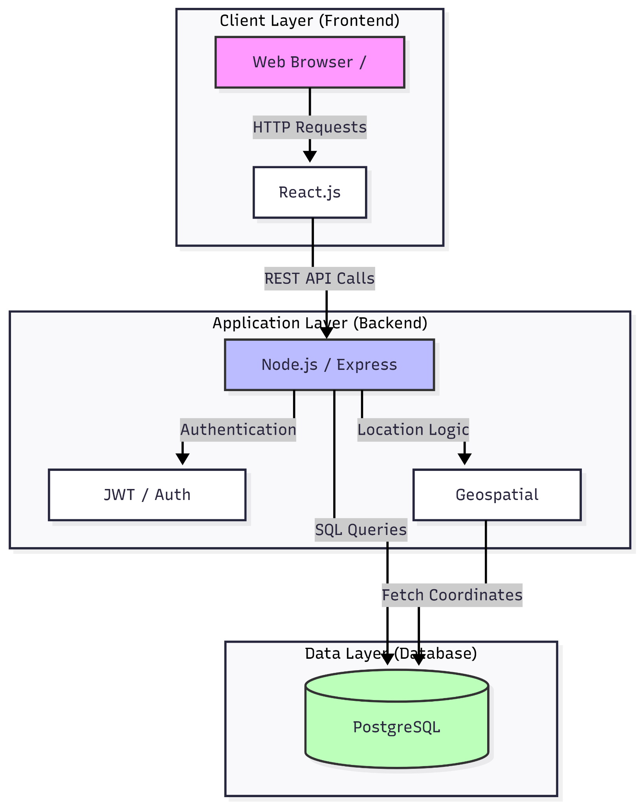
Fig. 1.1 High-Level System Architecture

  - Use Case Diagram: Illustrates how users interact with different modules of the system.

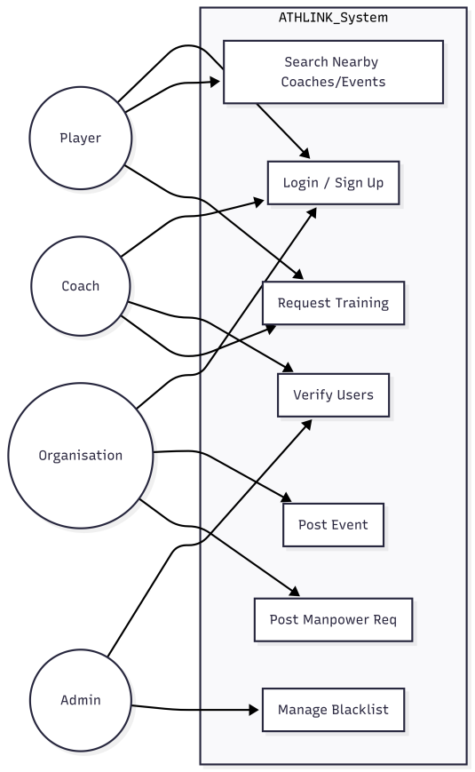

Fig 1.2

- Data Flow Diagram (DFD): Represents the flow of the project

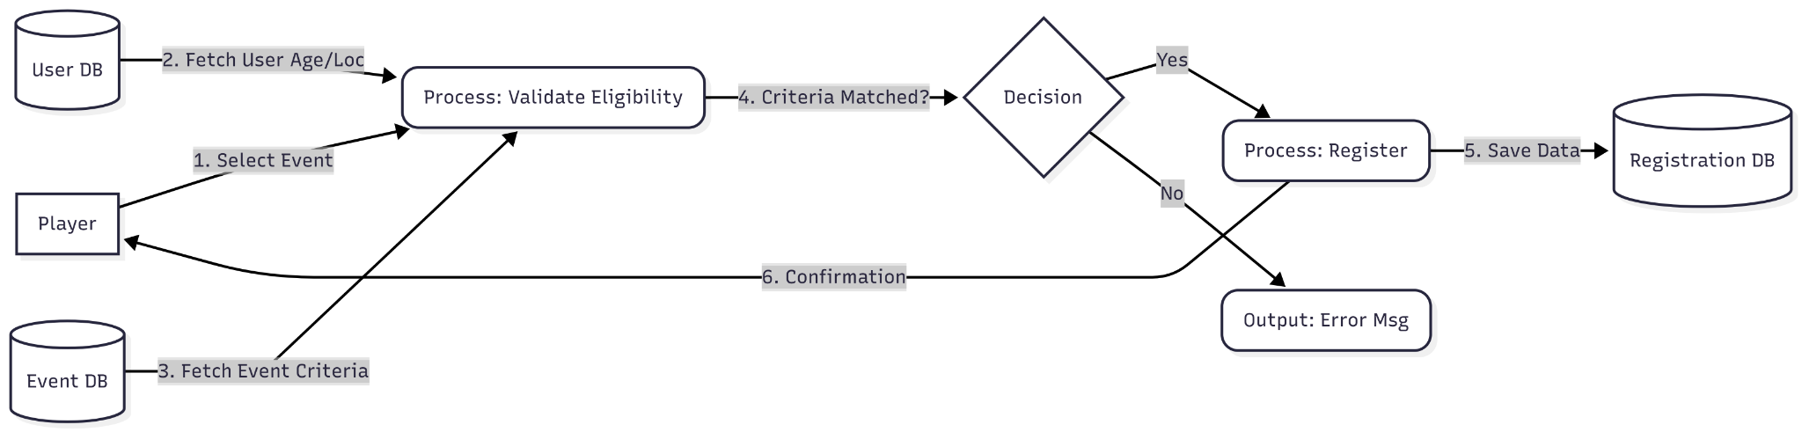

Fig 1.3

- Entity Relationship Diagram

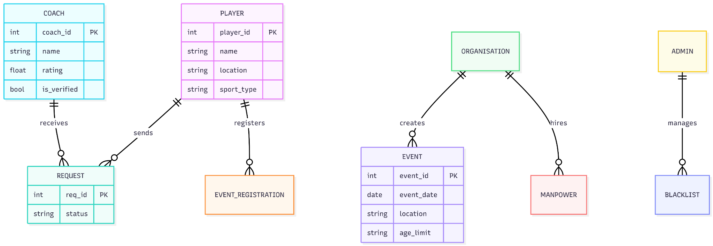

Fig 1.4

CHAPTER IV

System Requirement

Software Requirements
The development and execution of the ATHLINK platform require several software tools and frameworks that support web application development, database management, and system deployment.
- Operating System: The platform and its development environments are cross-compatible and can operate on Windows, Linux, and macOS.
- Frontend Technologies: The user interface is developed to be interactive and responsive across modern web browsers. Technologies include:
  - HTML for structuring web pages.
  - CSS for styling and layout design.
  - JavaScript for dynamic client-side functionality.
  - React.js for building component-based user interfaces.
- Backend Technologies: The backend layer processes user requests, manages authentication, handles event registrations, and controls system operations. Technologies include:
  - Node.js as the runtime environment.
  - Express.js framework for building RESTful APIs.
- Database Management System: The system uses a relational database (PostgreSQL or MySQL) to store and manage structured data, including:
  - User profiles and training requests.
  - Event details and organizational data.
  - System logs.
- Development Tools: Essential tools for coding, version control, and dependency management include Visual Studio Code, Git, and Node Package Manager (NPM).

- Web Browser: Modern web browsers are required to run and test the application, such as Google Chrome, Mozilla Firefox, or Microsoft Edge.

4.2 Hardware Requirements
The hardware requirements specify the minimum system configuration necessary to develop and run the ATHLINK application efficiently.
- Processor: A modern multi-core processor (Intel Core i5, AMD Ryzen 5, or higher) is recommended to simultaneously run the frontend server, backend API, and database without bottlenecking.

- Memory (RAM): A minimum of 8 GB RAM is required to run development tools and application services smoothly.

- Storage: A minimum of 20 GB of available storage is necessary for the operating system, development tools, application files, and local database storage. An SSD is highly recommended for faster application loading and data retrieval.

- Network Connectivity: A stable internet connection is required for downloading development dependencies, testing web application features, and accessing documentation.

Expected Outcomes

The deployment of the ATHLINK platform is anticipated to yield several significant improvements for all stakeholders within the sports industry. By bridging the gap between players, coaching professionals, and organizations, the system aims to deliver the following key outcomes:

5.1 A Centralized Sports Ecosystem
- Reduced Fragmentation: ATHLINK will successfully replace the reliance on disjointed social media groups and disparate websites by providing a single, unified digital space.
- Streamlined Networking: Players, coaches, academies, and organizations will be able to seamlessly connect and interact within a structured environment.
5.2 Enhanced Opportunity Discovery
- Targeted Accessibility: Players will experience a simplified process for locating local coaches, academies, and competitions through the platform’s advanced, parameter-based search system (filtering by sport, region, age, and experience).
- Increased Visibility: Sports organizations will benefit from higher visibility when promoting events, trials, sports camps, and open positions for volunteers or interns.
5.3 Streamlined Communication and Management
- Efficient Trainee Management: Coaches and academies will be able to systematically receive, review, and manage training requests, significantly reducing administrative overhead.
- Simplified Event Administration: Organizations will have access to dedicated tools to easily create, launch, and manage sports events and manpower requirements.
5.4 A Secure and Scalable Platform
- Role-Based Integrity: The implementation of Role-Based Access Control (RBAC) will ensure that users only access features appropriate to their status, maintaining high system security and data privacy.
- Administrative Oversight: Platform administrators will be equipped to successfully monitor activities, validate profiles, and enforce policies, resulting in a reliable and trustworthy community.
- Future-Ready Architecture: The system is expected to comfortably handle concurrent users while remaining flexible enough for future integrations, such as mobile applications and advanced analytics.

CHAPTER VI

Conclusion & Future Scope

6.1 Conclusion
The ATHLINK project successfully addresses the deep fragmentation within the current sports networking ecosystem. By developing a unified, role-based digital platform, ATHLINK bridges the gap between players, coaches, academies, and sports organizations. The system eliminates the reliance on scattered social media channels and disjointed websites, offering a centralized hub where users can easily discover opportunities, manage training requests, and organize sports events. Through its secure architecture and intuitive search functionalities, ATHLINK effectively democratizes access to grassroots and collegiate sports, providing a much-needed management tool for the entire sports community.
6.2 Future Scope
While the current implementation of ATHLINK provides a robust foundation for opportunity discovery and professional networking, the platform is designed with a scalable architecture to accommodate significant future enhancements. Planned upgrades for subsequent versions include:
- Advanced Event Management: Integration of automated match scheduling systems and real-time scoring trackers for tournaments.
- Financial Integration: Implementation of secure online payment gateways to facilitate seamless event registrations and coaching fee transactions directly through the platform.
- Artificial Intelligence (AI): Developing AI-driven recommendation engines to provide personalized suggestions for coaches, training camps, and events based on a player’s historical data and preferences.
- Mobile Accessibility: Expanding the web-based system into dedicated native mobile applications (iOS and Android) to improve on-the-go accessibility and push notifications.
- Communication Systems: Adding integrated, real-time messaging modules to allow direct, secure communication between stakeholders without leaving the platform.
- Data Analytics: Incorporating advanced data analytics and performance tracking modules to help coaches and organizations measure engagement and trainee progress.

CHAPTER VII

Reference

• React.js Official Documentation: Meta Platforms, Inc. "React – A JavaScript library for building user interfaces." Retrieved from: https://reactjs.org/
• Node.js Official Documentation: OpenJS Foundation. "Node.js API Reference." Retrieved from: https://nodejs.org/en/docs/
• Role-Based Access Control (RBAC): Ferraiolo, D. F., & Kuhn, D. R. "Role-Based Access Controls." 15th National Computer Security Conference, 1992.
• Agile Methodology: Beck, K., et al. "Manifesto for Agile Software Development," 2001. Retrieved from: https://agilemanifesto.org/
• Database Management (PostgreSQL/MySQL): "PostgreSQL: The World's Most Advanced Open Source Relational Database." Retrieved from: https://www.postgresql.org/

Abstract

In the rapidly evolving digital gaming industry, mobile gaming platforms have gained significant popularity. However, most existing platforms lack a centralized system that integrates multiple game modules while also providing social features such as friend lists, chat, and achievements. The Blitz Gaming Platform is an innovative Android-based gaming hub designed to address this gap by offering a unified platform where users can play, interact, and track their progress across multiple Unity-based games.
This project introduces a feature-rich mobile application developed using Java and XML in Android Studio, leveraging RecyclerView for game listings, ViewPager2 for smooth navigation, and SQLite for local database management. The platform includes a secure authentication system, allowing users to sign up, sign in, and store their progress. Additionally, Blitz provides a friend system where users can connect, view profiles, chat, and share recent gaming achievements through an integrated story feature.
Key functionalities of the Blitz Gaming Platform include:
      - Game Integration: A centralized hub for launching and managing Unity-based game modules.
      - User Authentication: Secure login and sign-up system with local data storage.
      - Social Features: Friends list, chat system, and recent achievements display.
      - Smooth UI/UX: Enhanced navigation with animations and transitions for an engaging experience.
      - Offline Data Storage: SQLite integration to ensure user data is accessible even without an internet connection.
The expected outcome of this project is a highly interactive and engaging gaming platform that not only facilitates gaming but also encourages social interaction among players. Future enhancements include cloud-based multiplayer gaming, real-time push notifications, leaderboards, and AI-powered game recommendations. The long-term vision is to evolve Blitz into a comprehensive cross-platform gaming hub, integrating more advanced social and competitive gaming features.

